VIDEO PLAYING TEST
HOW TO
*****ATTENTION: Not all students need to send me a video. If you don’t want to or if you don’t have capabilities to record, simply play your test in class. *****

Due any time before the night prior to the in-class playing test at 11:59 pm.

Requirements
- Fingers on instrument, bow hand, and face (for identification) must be visible.
- Audio clear.
- Listen back and redo if necessary.
- Late work not counted.

HOW TO:
- Record yourself playing the playing test. (You can use a camera, phone, webcam…)
- Log on to your Geisler MS Google Email account. (Ex. am0082941@students.wlcsd.org)
- Click the checkered square at the top right of the screen. In the drop down menu there will be an option for “Drive”. Click “Drive”.
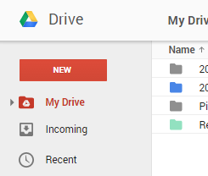
- Click “New” on the left side of the screen.
- A drop down menu will appear with options. Click “File Upload”. Find your file and it will download.
- ***Rename your file (by right clicking on the file) with this format “First Name Last Name – Hour – PT Name of the Test”***
Example: “John Smith – 2nd hour – PT #176”
“PT” stands for Playing Test
- After remaning the file correctly, select the file and click “Share”. The Share button looks like a person with a plus sign.
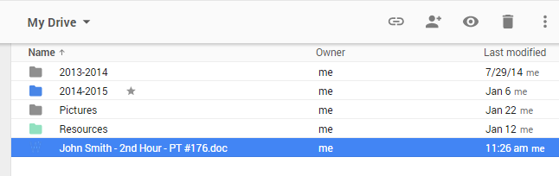

- Share with me at kellybriski@teachers.wlcsd.org.

If you have any questions please feel free to ask me in class or email me at kellybriski@wlcsd.org.
(This email is not my Gmail account with which you are sharing your video playing tests.)

